# 

# 

# 

# PATAN COLLEGE FOR PROFESSIONAL STUDIES

# Individual Reflective Report

# 

# 

# Ujaalo Student Information Kiosk

# PROJECT REPORT

# Submitted by Submitted to

# Prajwol Thapa (1721479) University of Bedfordshire

# 

**Individual Reflective Report**

This form is submitted by every member of your group and used to assess the level of teamwork in your group and the contribution of individuals. It may also form the basis of discussions which affect the grades received by individual group members.

|  |  |  |  |
| --- | --- | --- | --- |
| Student Number | First Name | Last Name | Group No |
| 1721479 | Prajwol | Thapa | 1 |

University of Bedfordshire has given us the assignment of developing Student Information Kiosk Software in Level – 5 Semester II. Student Information Kiosk will help the student as well as people of that community by making them aware of events occurring in both inside campus premises and within community. Along with that they can get the information of University and its campuses.

As this assignment is group assignment, I am very glad to have Kshitij Bajagain Lokendra Dangi, Buddha Lama, and Prabin Chapagain as my team partners and share my knowledge with them. It was really a new experience for me to work in this project and with such talented friends as group partner. At first, I was in confusion If I can work properly in group or not but working with team members made my work easy and smooth. With our frequently group meeting we discussed all requirements of the project and sliced all the work into equal portion for every team member in every sector of development. Our good group coordination and routinely scheduled team meeting and division of work in each member equally was the key of our software development.

**Work Division**

|  |  |  |  |
| --- | --- | --- | --- |
| **S. N.** | **Name** | **GUI &**  **Implementation** | **Diagrams &**  **Documentation** |
| 1 | Kshitij Bajagain | Student Dashboard , Events & Booking, My/All Booking , Account Details ,Clubs , Admin Dashboard design and their functionalities | ER Diagram, Class Diagram, Design and implementation, work division. |
| 2 | Lokendra Dangi | Add Events , Alter Events , Update Events, Delete Events design and their functionalities | UseCase Diagram, Class Diagram, Introduction of report, Testing part. |
| 3 | Buddha Lama | Register Page , Login Page , Why Us , Help, Brochure, Accommodation , User Information(admin) design and their functionalities | Sequence Diagram, Class Diagram. Project plan. |
| 4 | Prabin Chapagain | Browser Functionality , Campuses (Luton, Bedford, Aylesbury, Milton Keynes, Putter ridge , Patan College) ,Education Loan | Activity Diagram, Class Diagram, agile and primary research. |
| 5 | Prajwol Thapa | Splash Screen , Kiosk Main Home Courses(Undergraduate , graduate , Foundation and International Students) , Invoice Generation | Sequence Diagram, Class Diagram, aims and objectives and critical analysis. |

During the time periods of this project each group member of my team has contributed according work division we have assigned (mention as above). My work with screenshots along with code snippets are mentioned in my contribution part of this individual reflective report.

**Conclusion**

It was a wonderful experience for me to work in such group and hope to work with them again in future. During the time period of this project I have learned how to work in team, how to communicate properly with team members. And I had also got an opportunity to share my own ideas and receive good suggestion from my team members. Moreover, it was big opportunity for me develop my teamwork skills and communication skills.

**Evaluation**

During the time periods of this software development each group members have worked very hardly and keeping a good team effort. And evaluating the work and contribution of each group I have attested a table below which rates their work during project development.

|  |  |  |  |
| --- | --- | --- | --- |
| Student Number | First Name | Last Name | Contribution  (N, S, I) |
| 1723333 | Kshitij | Bajagain | S |
| 1720849 | Lokendra | Dangi | S |
| 1721484 | Prabin | Chapagain | S |
| 1723936 | Buddha | Lama | S |

**S** -Significant (The group member’s work was integral to the overall submission)

**N** -No Contribution (The group member took no part in the project submission)

**I** -Insignificant (The group member’s work made little difference to the overall submission)

**UML Diagrams(Class Diagram):**

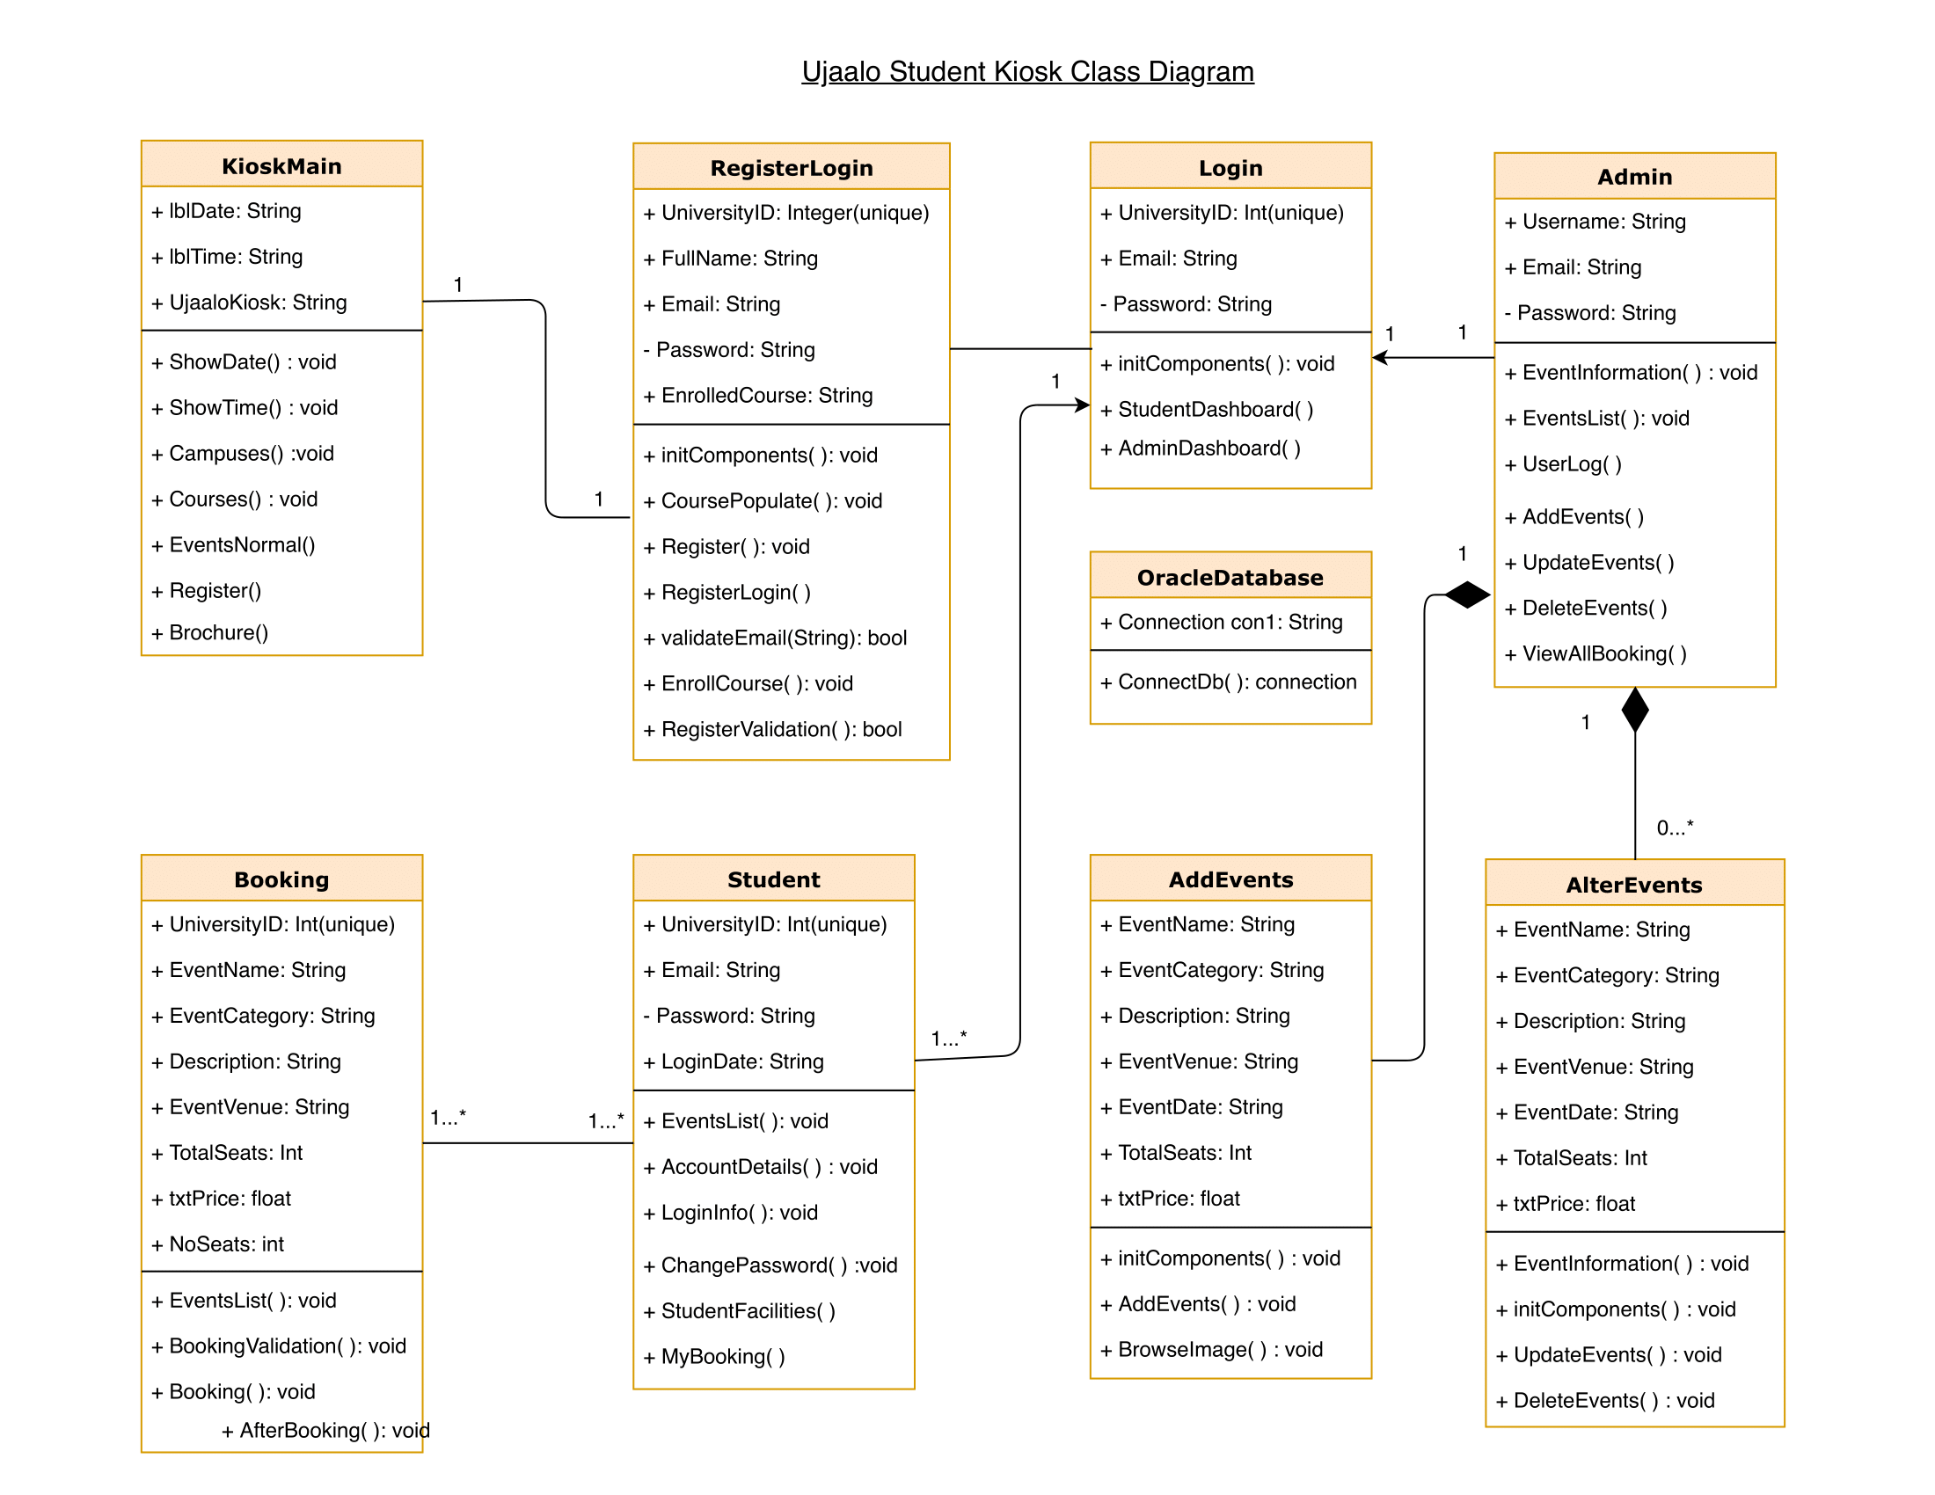

1. **GUI Templates:**

These are the functions that I have did during software development

1. Kiosk Main Page :

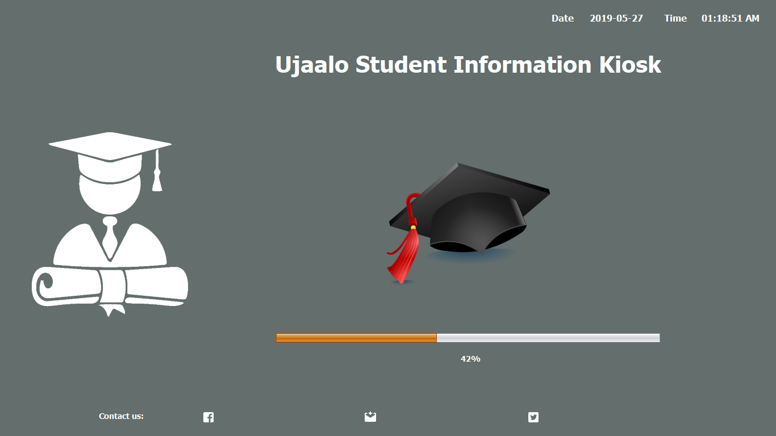

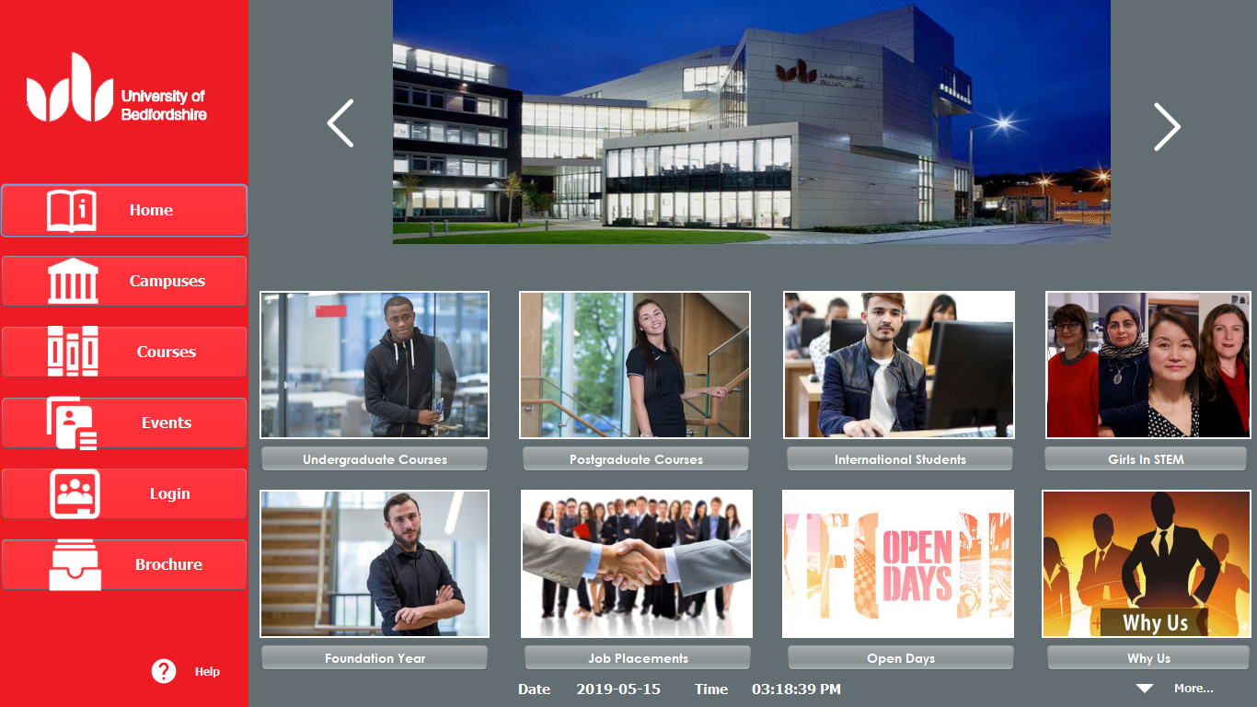

2>Courses:

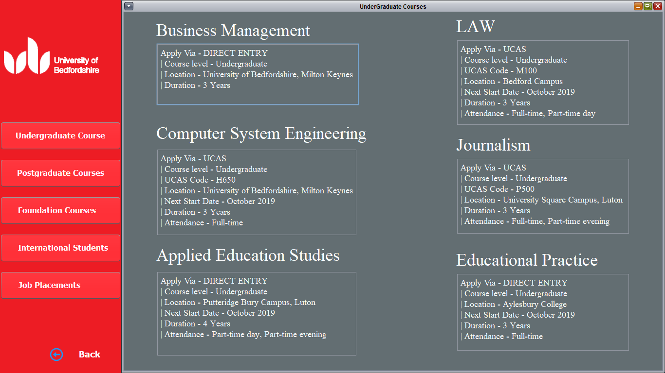

3> Campus Services:

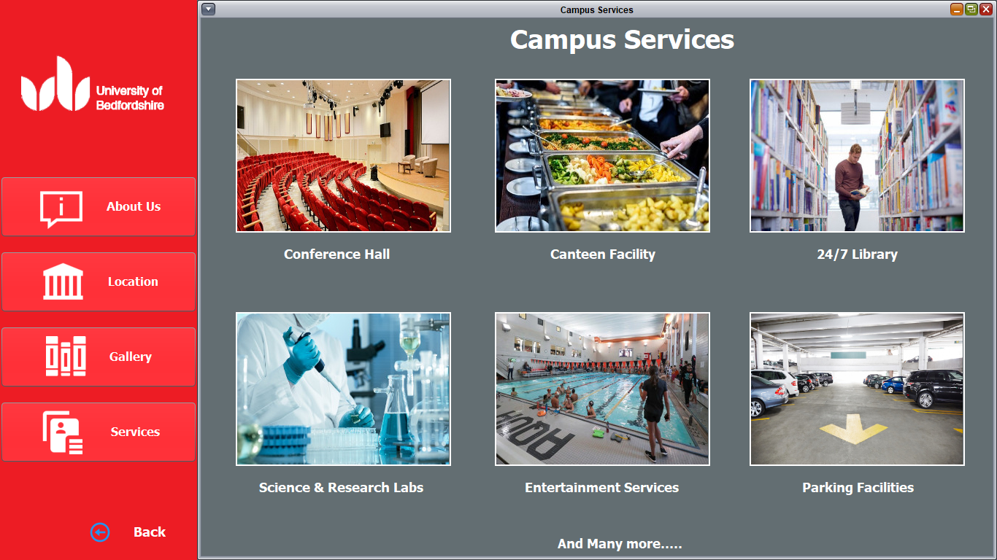

4>Invoice Generation:

